 **---------------------------------------------------------------------**

**Learn Crypto currency by Vaibhav**

**---------------------------------------------------------------------**

**Business Flow of the Application.**

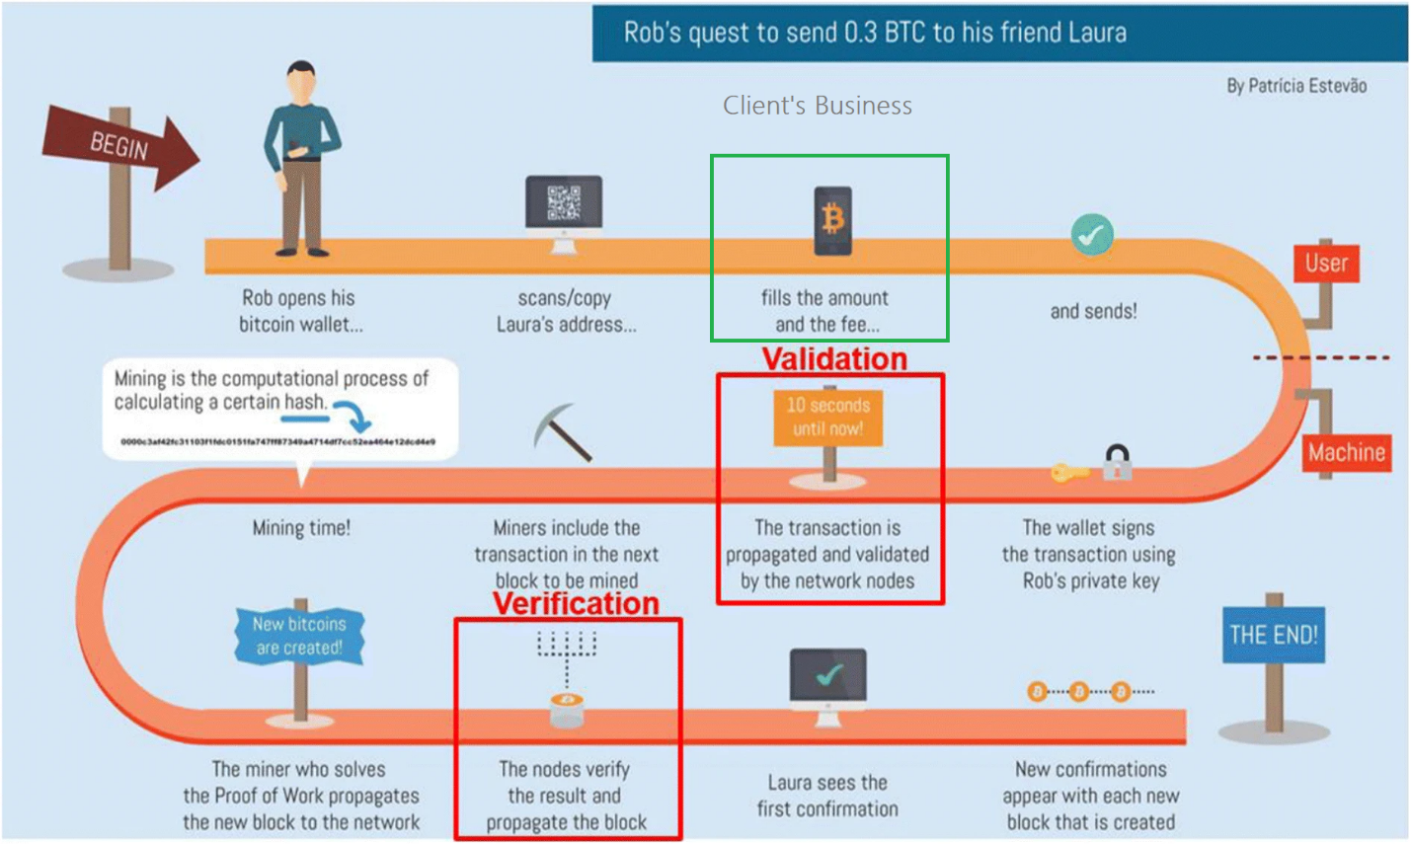

* Business Flow: When any Transaction Successful 🡪 Client charges **0.2 Maker Fee and 0.2** **Taker Fee** for Each transaction **(Crypto Currency Buy and Sell).**
* Client also charges few % (0.005 Percent) for Send any Crypto currency.

-----------------------------------------------------------------------------------------------------------------

1. What is **Crypto** currency?

Digital/Virtual currency in which **transactions** are verified and records maintained by a decentralized system. (**Block Chain**)

Using **Crypto currency** – One Can -🡪

* Buy
* Sell
* Send
* Receive.

-----------------------------------------------------------------------------------------------------------------

**In the Project I have worked on:**

1. Buy and Sell Module (Exchange Module)
2. FUNDS Module🡪 Send(**Withdraw**) and Receive(**Deposit**) Module (Transfer Module –Withdraw and Deposit)
3. Peer to Peer Module
4. Funds Module
5. **Profile Module**
6. Graph Module

----------------------------------------------------------------------------------------------------------------

1. **Buy Module**

Consider One Scenario 🡪

|  |  |  |
| --- | --- | --- |
| **BUY** | **Result** | **SELL** |
| 1 User 🡪 1 Bitcoin Purchase @1000 | No Match between Buyer and Seller 🡪 Order Opened 🡪 **Order Cancelled. Order Not Executed** | 1 User 🡪 1 Bitcoin Sell @1200 |
| 1 User 🡪 1 Bitcoin Purchase  @1000 | As Buying Price is more🡪 The will instantly **Executed**.   * Order Complete | 1 User 🡪 1 Bitcoin Sell  @900 |
| 1 User 🡪 1 Bitcoin Purchase  @1000 | Buy Price and Sell Match 🡪 Order Complete and Executed. | 1 User 🡪 1 Bitcoin Sell  @1000 |
| 1 User 🡪 1 Bitcoin Purchase  @1000  Buyer give 🡪 1000  Later WazirX return 500 RS | Only 0.5 Bitcoin buy by the Buyer. And Rest Amount is credited to Wallet. Seller Sell the 0.5 Bitcoin.  Order 🡪 Partially Executed. | 1 User 🡪 0.5 Bitcoin Sell  @1000 for 1 Bitcoin.  Seller will get 🡪 500 |
| 1 User 🡪 0.5 Bitcoin Purchase @1000 per Bitcoin  Buyer will pay 🡪 500 Rs | Only 0.5 BTC sold to Buyer.  Order 🡪 Partially Executed. | 1 User 🡪 1 Bitcoin Sell  WazirX give 500RS(0.5 BTC Sold) and Will return remaining **0.5 BTC** |

1. To verify selected coin/currency highlighted when select any currency.
2. To verify “Buy” tab default selected when select any currency.
3. To verify “Lowest Price” displayed of the Selected Currency.
4. To verify Wallet balance displays near Wallet Icon.
5. To verify Amount and Total INR fields displays Null when opened.
6. To verify Selected Coin Name displays on Buy button.

**Buy :**

1. Total INR = AT PRICE * AMOUNT
2. Amount = TOTAL INR / AT PRICE

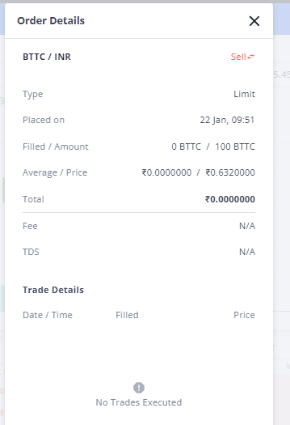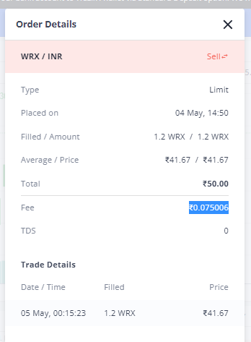

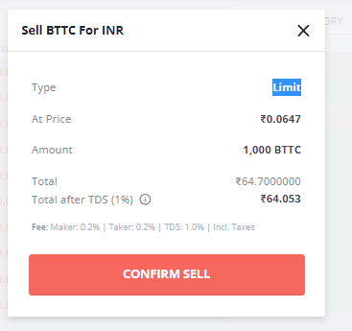

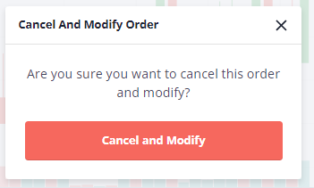

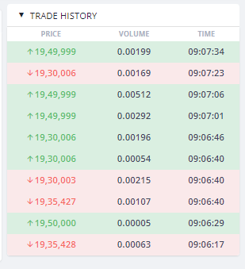

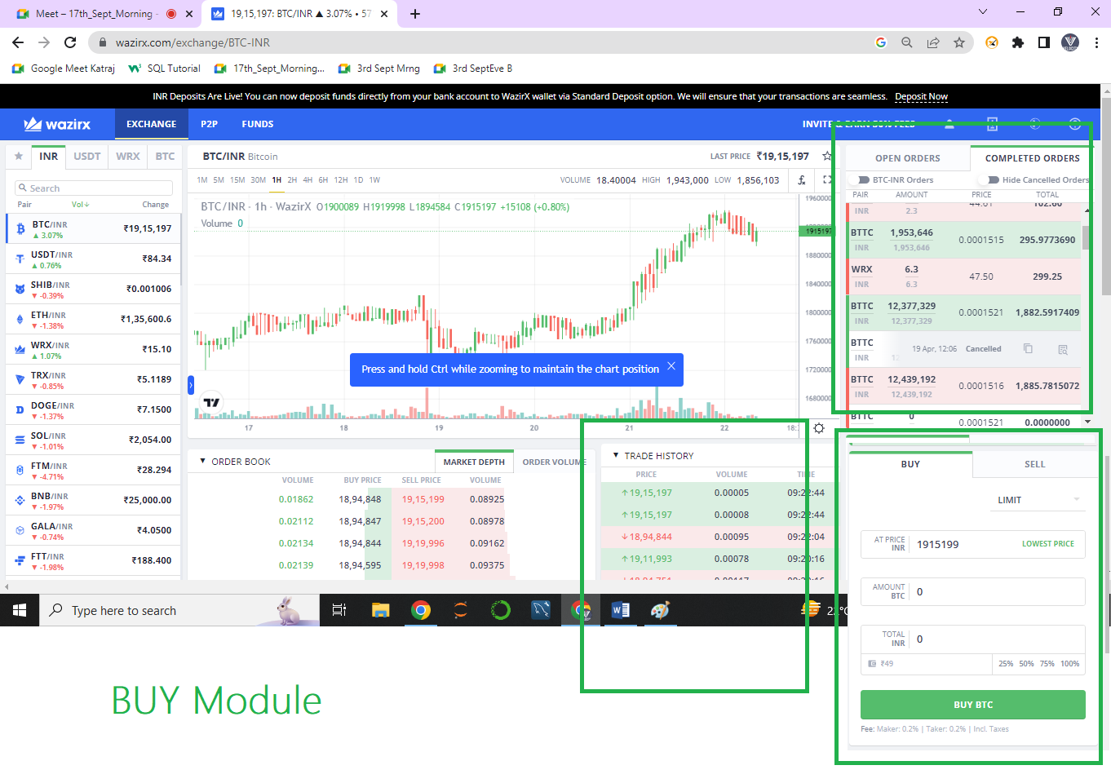

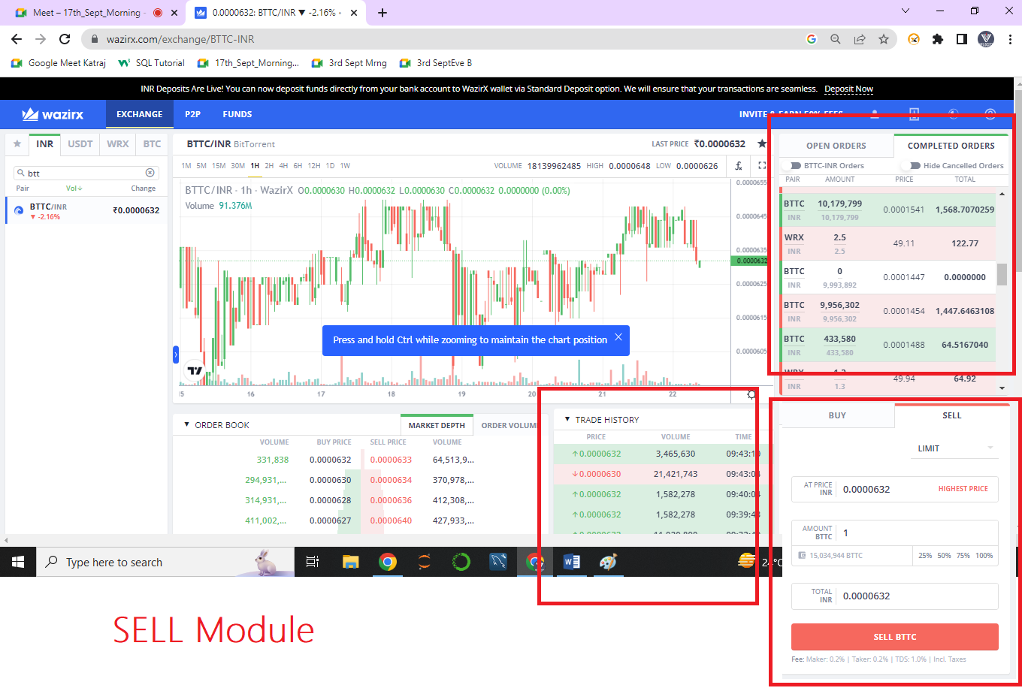When User placed one Buy Order 🡪 **Buy** Bitcoin at **RS 1000** order Placed and **Seller** Prices Ranges from Min **5000-5500**Max Rs Varies.

1. Placed Buy Order 🡪 Displayed in “**Open Order**”. 🡪 After 24 Hours if order not executed 🡪 **Completed and Cancelled.**
2. Placed Buy Order 🡪 Displayed in “**Open Order**” 🡪 In 24 Hours duration if order executed 🡪 **Completed and Executed.**

If User want to Buy any Crypto currency 🡪 INDIAN RS must be available in your Wallet.

If User want to Sell any Crypto currency 🡪 Selected Crypto Currency must be available in your Wallet.

**Placed Order. 🡪 Open Orders.**

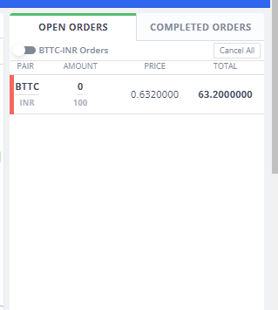

---------------------------------------------------------------------------------------------------------------------

**FUNDS Module**

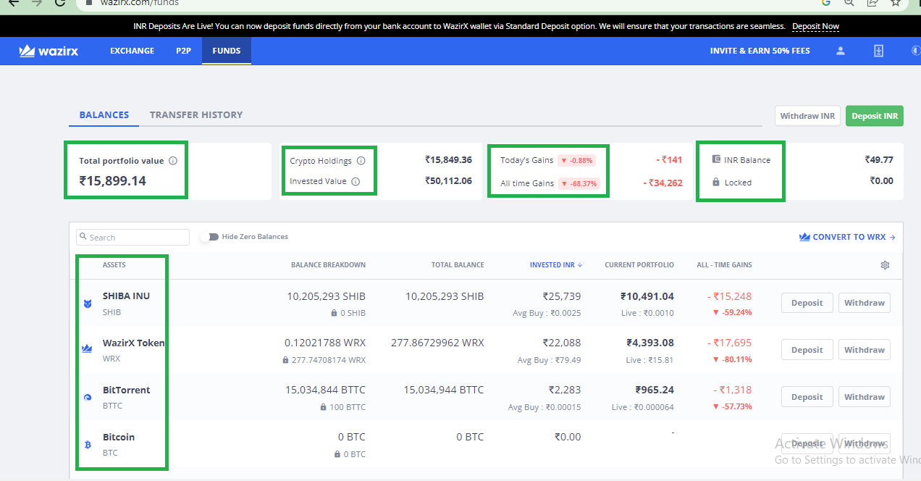

ALL TIME GAIN = Current Portfolio (Crypto Holding) – All Time Investment

Current Portfolio = Current Coin Price * Total Balance (**Coin**)

Investment INR = Total No of Time you have purchased the Currency.

Crypto Holding = Addition of all the Coin’s Current Portfolio Values.

Invested Value = Addition of the Invested INR for ALL Coin.

Total Portfolio Value = Addition of All Current portfolio Value.

**Transfer History.**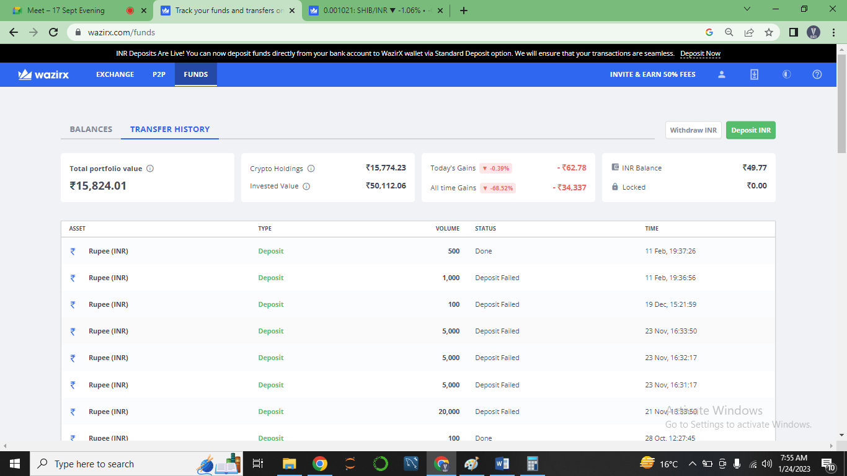

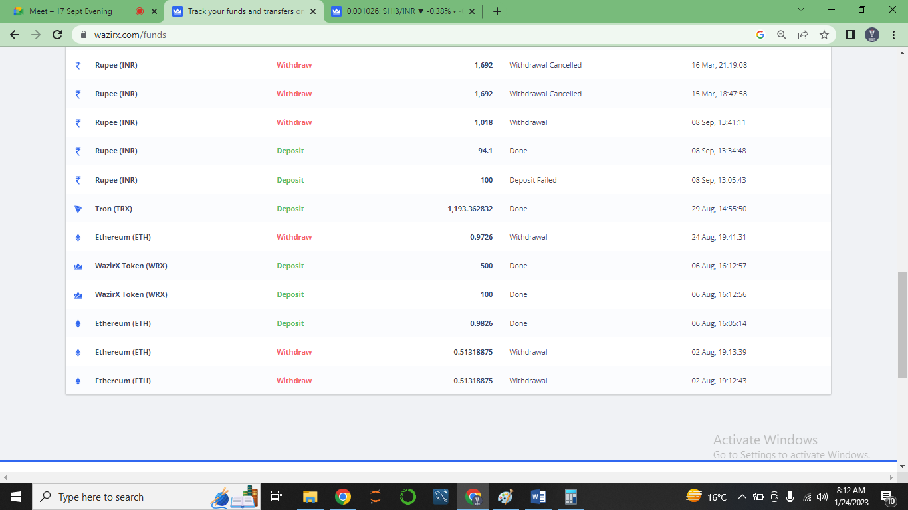

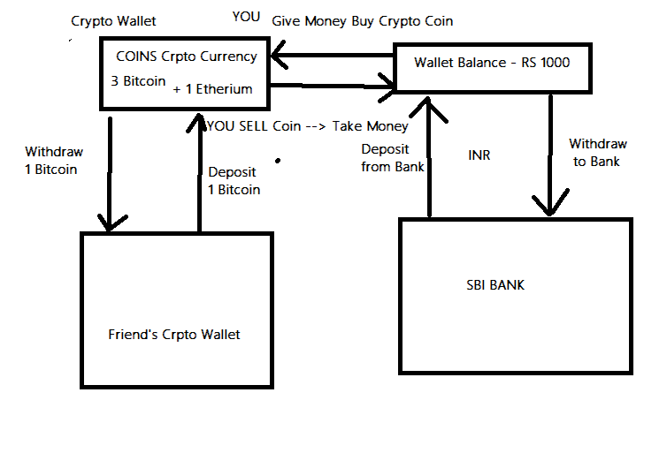

**WITHDRAWAL and DEPOSIT FOR INR**

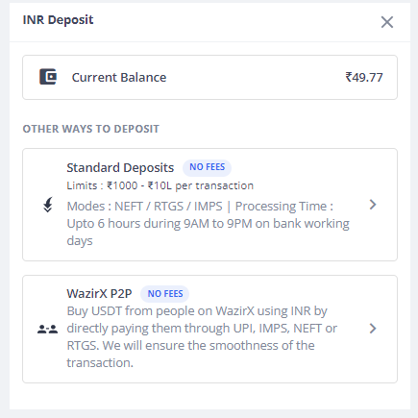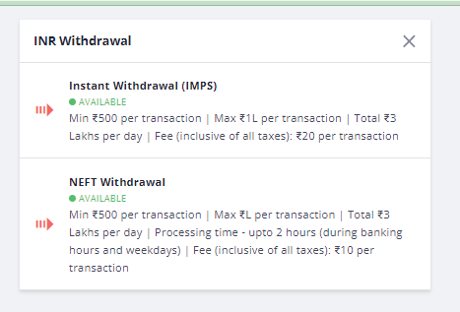

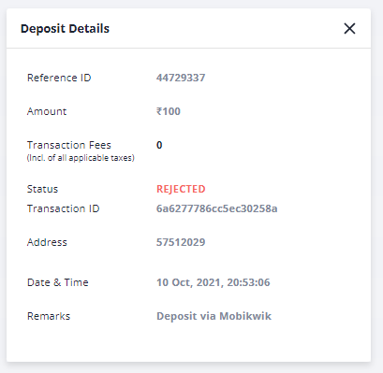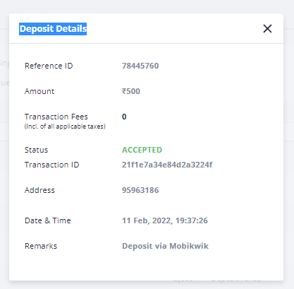

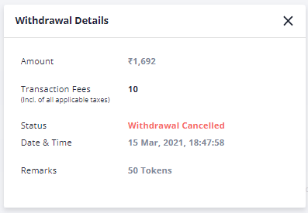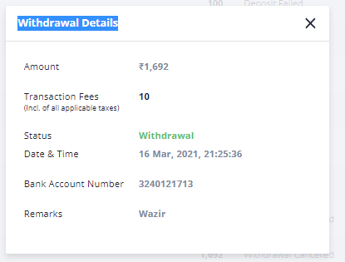

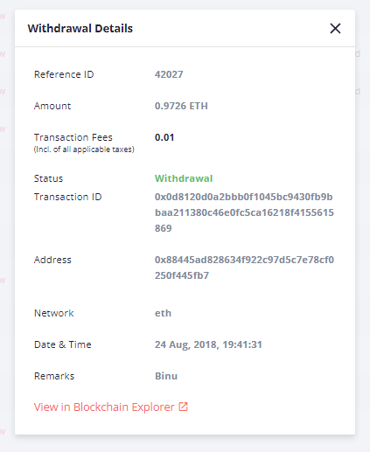

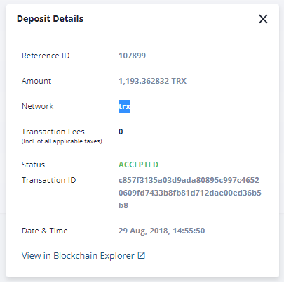

[**https://etherscan.io/tx/0x0d8120d0a2bbb0f1045bc9430fb9bbaa211380c46e0fc5ca16218f4155615869**](https://etherscan.io/tx/0x0d8120d0a2bbb0f1045bc9430fb9bbaa211380c46e0fc5ca16218f4155615869)

[**https://tronscan.org/#/transaction/c857f3135a03d9ada80895c997c46520609fd7433b8fb81d712dae00ed36b5b8**](https://tronscan.org/#/transaction/c857f3135a03d9ada80895c997c46520609fd7433b8fb81d712dae00ed36b5b8)

**---------------------------------------------------------------------------------------------------------------------------**

**Sample User Story**

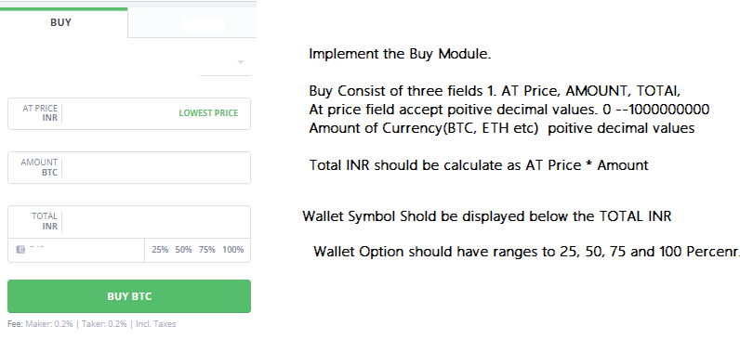

**Business Flow Application.**

* **Whenever any end user place an order (Trade an order buy and sell) charges 0.2 % maker fee and 0.2 taker fess per transaction.**
* **If any user transact any currency (Withdrawal) to another platform/ another crypto wallet so depends upon the currency charges applied on transaction.**

**Technical Flow Application.**

* **Buy Module: In the buy module any selected currency/ Coin can be traded (Buy).When an buy order placed initially it displays on Open order module/page.   
  If the placed order successfully executed then it displays as Executed in Completed order page/module.**
* **If the placed order is somehow cancelled it displayed as Cancelled in Completed order page/module.**
* **Sell Module: If any user want to sell the Currency /coin; Make sure User possess the coins 🡪 User place a sell order by entering At Price and Amount values.  
  if Buy Price and Sell Prices matches then Order Executed and Moves to Completed Order section from Open order.**
* **On the Left Pane; all Listed coins displays.**
* **Funds Module: Whenever any user buyed any currency it displays in Funds module under Asset Tab. If any User buyed multiple coins like Bitcoin, Etherium, Shiba Inu etc all the coins displays in Asset tab.**